In a MotionMD Integrated account, when searching for a patient by MRN, there are occasions when the patient cannot be found. This should be an infrequent occurrence. If presented with this scenario, the recommendation is to manually create the patient in MotionMD. On a manually created patient, be sure to add the patient’s MRN number. This is an important step in ensuring the patient record is updated in the system once integration issues have been resolved.

Additional steps to evaluate when troubleshooting missing patients:
Determine Trigger Events
Each interface has different Trigger Events. Some examples are Patient Registration, Patient Information Update, New Appointment Booking, Order Entry, etc.
If the trigger event does not occur, the patient will not show up in the system. In some cases, searching by MRN will initiate a trigger event, and a patient may be found. In other cases, updating the patient demographic may also initiate a trigger event.

Examine Purge Window
Review to see if the patient was created and/or updated within the purge window. To keep current records, integrated accounts are set up to purge unused patient records after a certain time, which can vary from 1 day to 90 days. Each account is configured to specify the number of days an integrated Patient record will stay in MotionMD without a Patient Agreement (PA) being created. If no PA is created for that Patient in that period of days, the Patient record will be purged. If a PA is created, the Patient record is not purged.
If a trigger event was enabled within the purge window, click on the Recent Patients tab to monitor, or view if any patients were integrated for the day. To find the Recent Patients page, follow these steps:
On the top navigation bar click on Clinical and select Recent Patients.
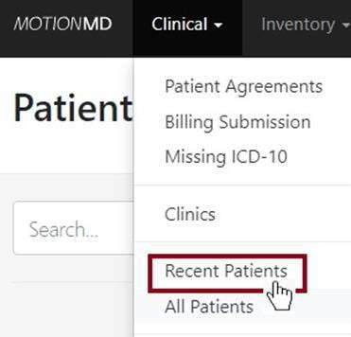

Click on a Patient.
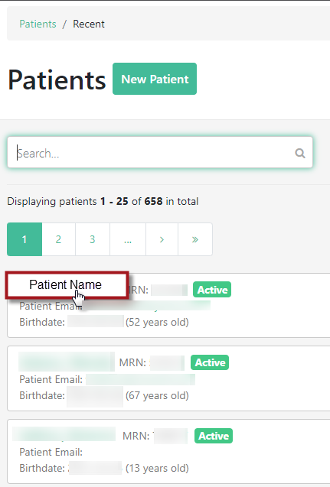

On the Patient Demographic page, check if the Creator shows as Integration. If you see Integration as the Creator, your interface is working and there may have been a workflow issue when entering a patient into the system. Please note that the Created Date and Timestamp provide the day and time the Patient Record was created by Integration.

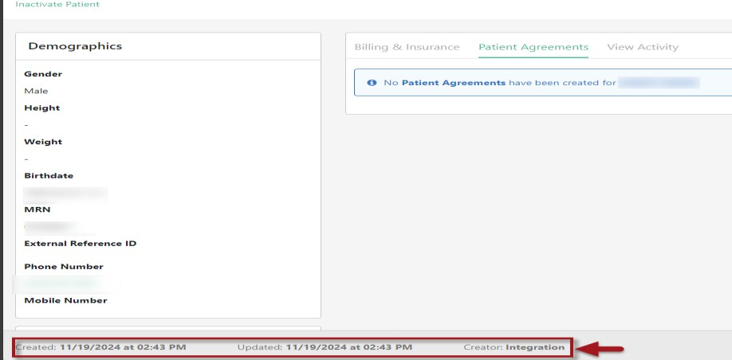

If the Creator shows as a staff member, the Patient Record was manually created so open an Integration Help Desk ticket: https://motionmd-direct.zendesk.com/hc/en-us.

NEW Location or Provider recently added
There are instances where a new department id, location or provider has been added to the account, which could impact patient integration. Monitor for any specific trends. Examples of this are the same provider or only one location is having issues with missing patients and note this on the Integration Help Desk ticket.
Integration is Down
If the Integration interface goes down, we will work with IT staff to resolve the issue in a timely manner. While the Integration interface is down, MotionMD can be operated in a manual fashion by entering patient demographics and insurance into MotionMD either via fact sheet attachment or typing in required fields.

